Basket Raffle
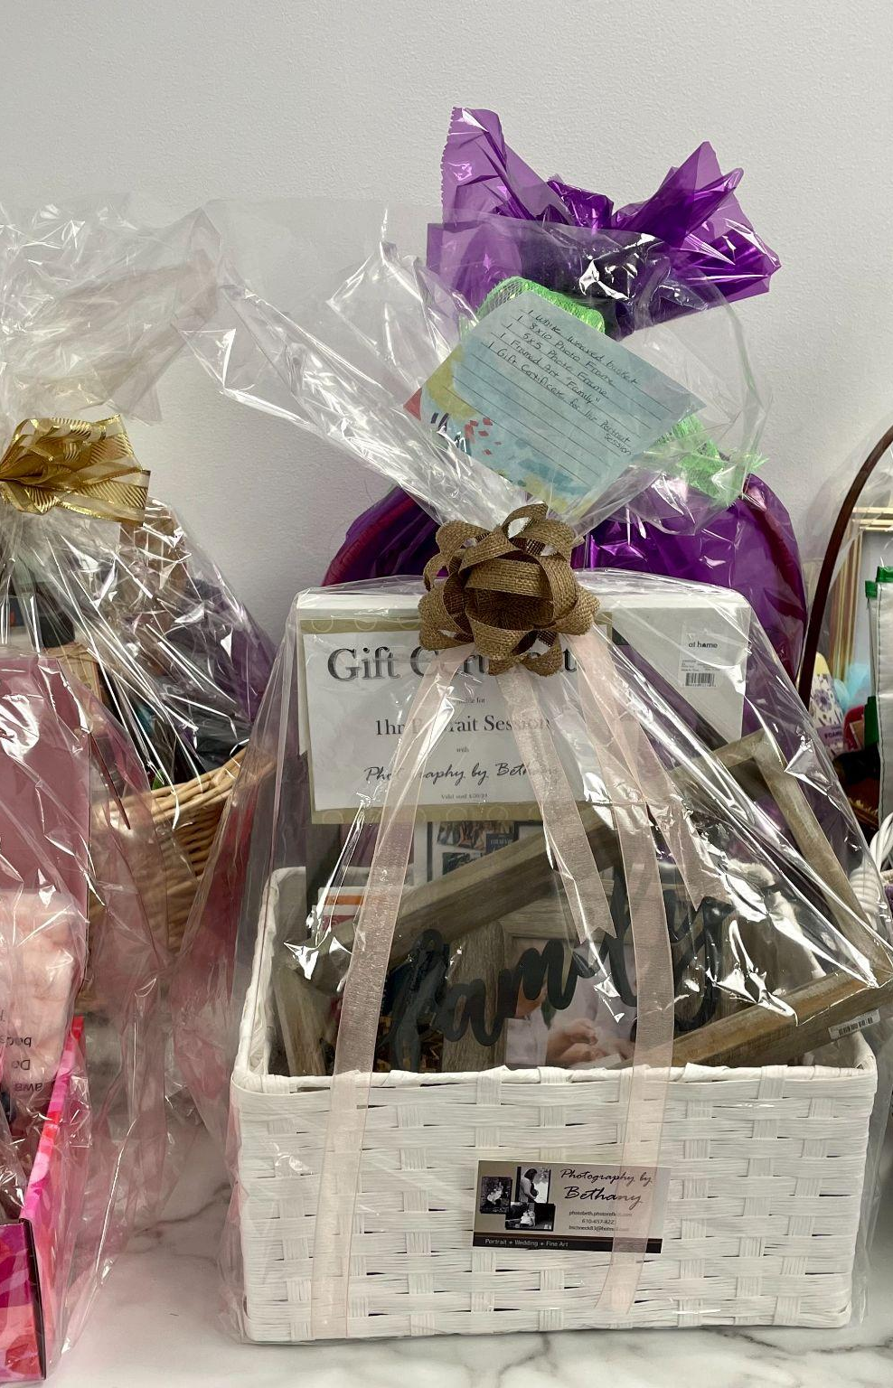
BASKET DROP OFF
Bright Hope Admin Office
2200 Hamilton Street
Suite 108
Mon – Thurs 8:30am – 2pm

Drop Off Deadline: April 10th

How to donate:
- Pick a basket from the options below or create your own theme.
- Use Sign Up Genius Link below to register a basket.
- Gather items as a small group, church, or individual.
- Email Amity at amity.bechtel@brighthope
centers.org or call 610-821-4000 with questions

BASKET THEME IDEAS
Movie Night, Spa Day, Kids’ Crafts, Gardening, Candy Lovers, Local Attractions, Coffee Lovers, Movie Night, Bookworm, Game Night, Hiking, Beach Day, Small Business, Cozy Box, Spoiled Dog, Golfing, Baking, International Cooking, Puzzles, Relaxing Crafts, Date Night, Teatime.

Sign Up Genius Link
https://www.signupgenius.com/go/10C0F45A5AC2EA2F5CF8-55206237-3rdannual#/

